Title: | Applied Information Technology 2a & 2b
Task/Lesson No. | Comparing Computers
Class: | Y11 AIT 2a & 2b
Area: | Technology & Enterprise
Teacher: | Mr Faulks
Phone:
Contact email:
Timeline:
Date Due: | 2 weeks
Task Notes: | Homework

Computer Comparison

THIS IS HOMEWORK

Print me out and take me home… or complete using MyClasses

Save a link on your site to this document as your initials_compare.doc

Due Week 4 Term 2 Wednesday or Thursday
You are to research the difference between two computer types, i.e.
Windows v Linux
Windows v Macintosh
Macintosh v Linux
Or v other

Choose either a lap top or desktop computer
You must consider all the aspects as a comparison and you may need to go to shops, internet or magazines to find information, include peripherals if required i.e. if one computer has built in speakers or video or a microphone then include the equivalent as peripherals if the other computer does not have inbuilt components. Match both including full price. Offer alternative choices if you wish. PLUS: Complete the quiz and include it in your answer. Create a cover page for this homework.

Complete this quiz
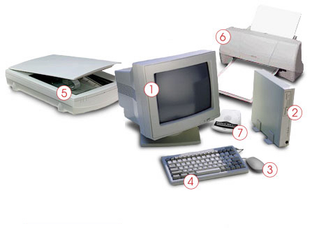
Identify the computer parts

1 CRT Monitor
2 Tower/Case
3 Mouse
4 Keyboard
5 Scanner
6 Printer
7 Modem

Background to help you

Computer basics
Computers vary from the very small to the very large. They can differ in the speed at which they process data, memory size, physical size and price. Some examples include handheld computers, laptops / notebooks, desktop computers, mainframes and supercomputers. The rapid development of technology means that even these categories of computers are changing.
All computers have some basic principles in common. They are all electronic devices that:
• take in input from a user in the form of data
• process data
• store data and
• make data available for output as information.

Data is the raw fact which we enter into a computer for processing. An example might be the runs made by a particular batsman in each cricket match that he plays.
Information is the meaningful knowledge we obtain from processed data. For example the batting scores in each cricket match (data) can be processed to inform us what that player’s batting average is.
Scroll your mouse over the diagram below for a simple plan of the basic components of a computer.

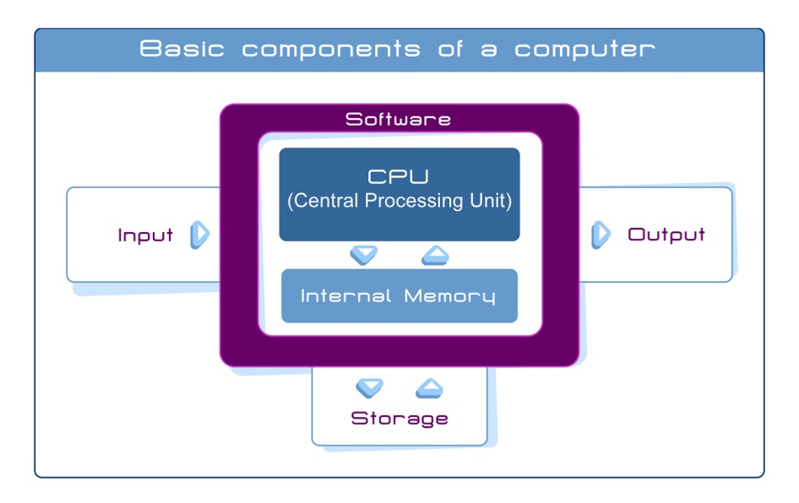

Computer components
What type computer equipment are you working on? It is probably a desktop computer or maybe a laptop. Your computer consists of hardware and software. Hardware is the physical component of your computer. It includes the parts of a computer we can touch, such as the systems unit containing the Central Processing Unit (or CPU), the keyboard, mouse, printer, chips, disks, etc.
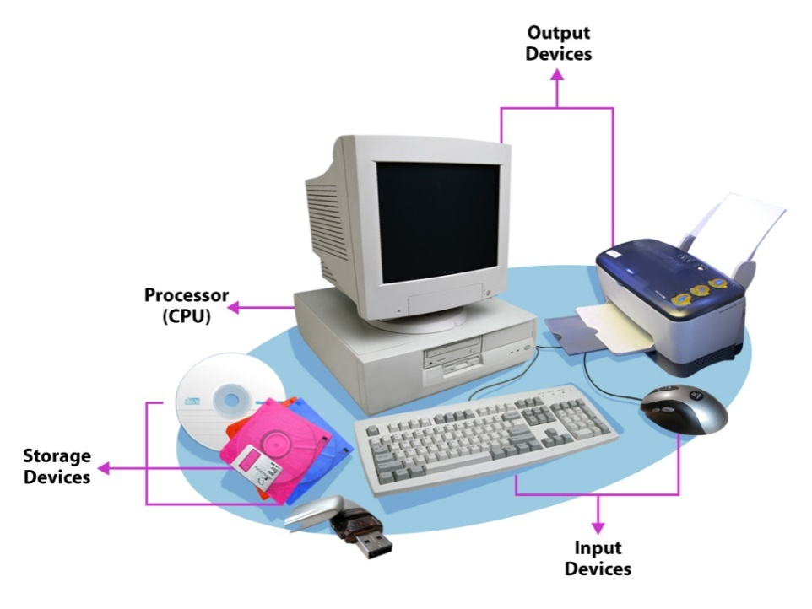
Software is the computer programs that makes the hardware work. Microsoft Word is an example of software. We will look at software more closely later in the week.
Hardware peripherals are those items
connected to the computer and controlled
by its CPU. Peripherals can be internal
such as sound cards and CDRoms or
they can be external. External
peripherals such as the monitor
and scanner, are connected via
cables or through wireless
connections such as some
keyboards and mice.

A typical desktop computer may consist of the following components:
Input Devices | The keyboard and mouse are used to input data into the computer. A scanner and digital camera can also be used for this purpose.
Processing | The system unit, or tower, contains the Central Processing Unit (CPU) which processes the data to produce information.
Output Devices | The monitor displays information and the printer allows you to produce a hard copy of that information. Both of these are output devices.
Storage Devices | The processed data can be stored on the hard disk inside the tower or can be stored on portable devices such as floppy disks, CDRoms or DVDs or USB thumb drives.

Understanding the desktop
Think about the desk that you work and study at. When you do your study, does it contain everything that you need? Can you move documents and folders around as you need them or even pile them up? Your computer desktop is the same.
The desktop is the screen (output device) on which the icons (small pictures of objects) are seen when you start up your computer.
The way your desktop screen looks is determined by the operating system your computer uses. Most operating systems now use a graphical user interface (GUI). This means that the programs, files and options are presented on the screen as icons, menus and dialogue boxes. These icons allow you to launch computer programs easily and quickly. You do not need to type precise commands, simply use a mouse to select the icon and click.

Apple® Macintosh® desktop
If you are using an Apple® Macintosh® Operating System, your desktop may look something like this:
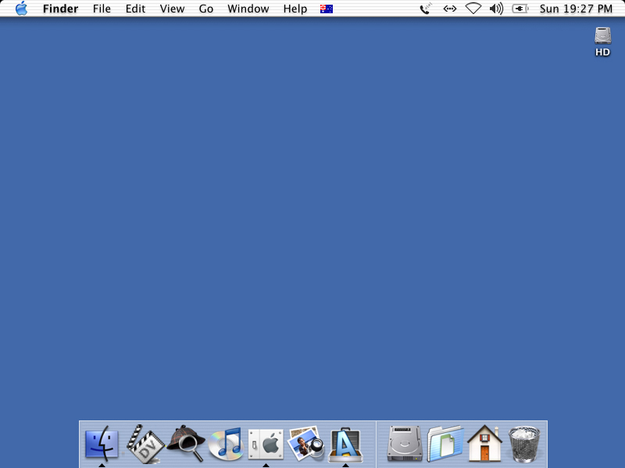

Linux®-based desktop
If you are using a Linux®-based Operating System, your desktop may look something like this Linspire® desktop.
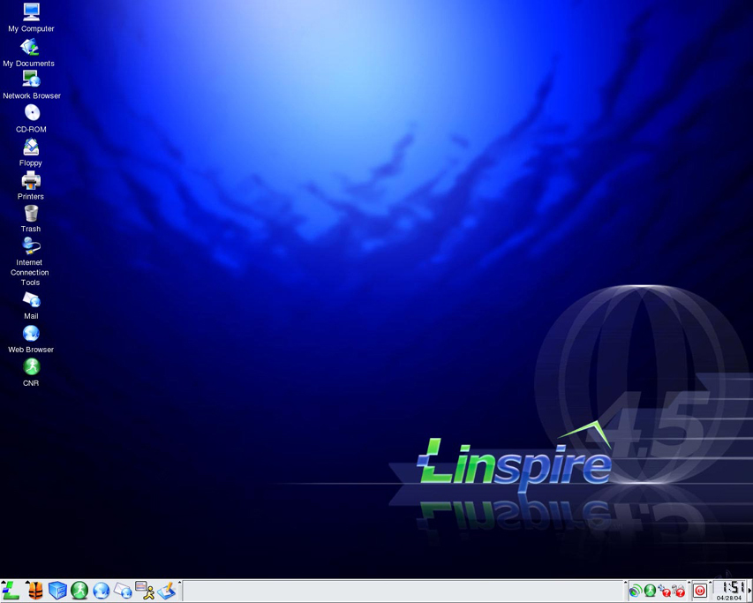

Microsoft® Windows® desktop
If you are using the Microsoft® Windows® Operating System, your desktop will look something like this:
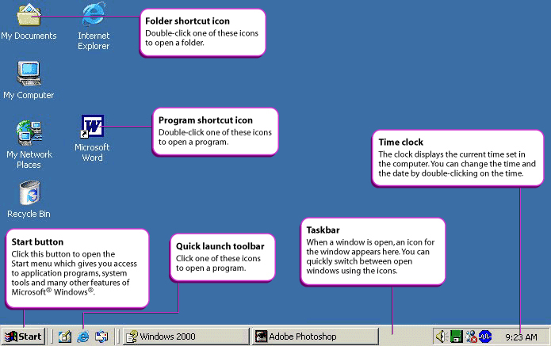
On the above diagram have a careful look at the icons described there.

Looking at windows
In a graphical user interface like Microsoft® Windows®, when you open a program, a document or a web browser, it appears on your desktop inside a window.
The following illustration shows a typical Microsoft® Windows® window. Most GUI operating systems use minimise, maximise and close buttons, however, they may not share the same toolbars or title bars.
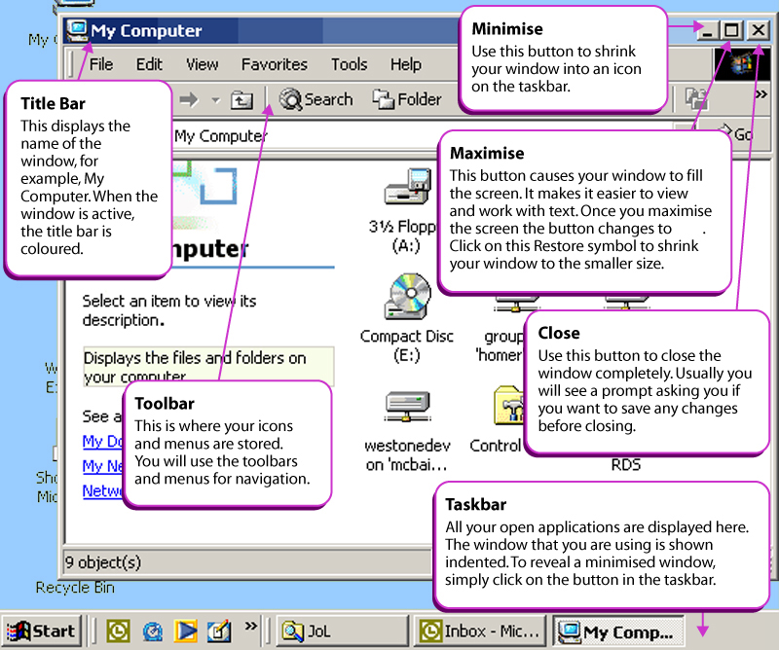

If you open an actual application, in this case Microsoft® Word, the information is opened in a window with a variety of features and toolbars.

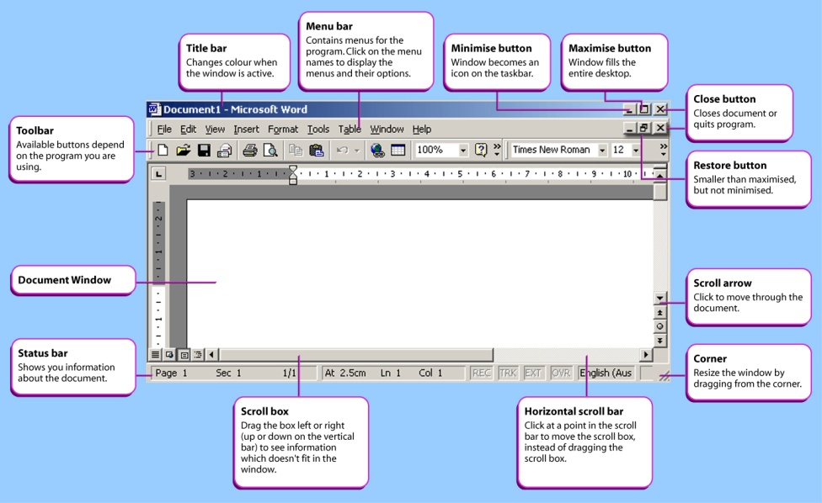Dialogue boxes
Dialogue boxes appear when some information is needed from the user. Dialogue boxes pop up and ask you to make a selection, or confirm an action, or sometimes they appear as a warning.
The following illustration shows a typical Microsoft® Word dialogue box for saving your work.
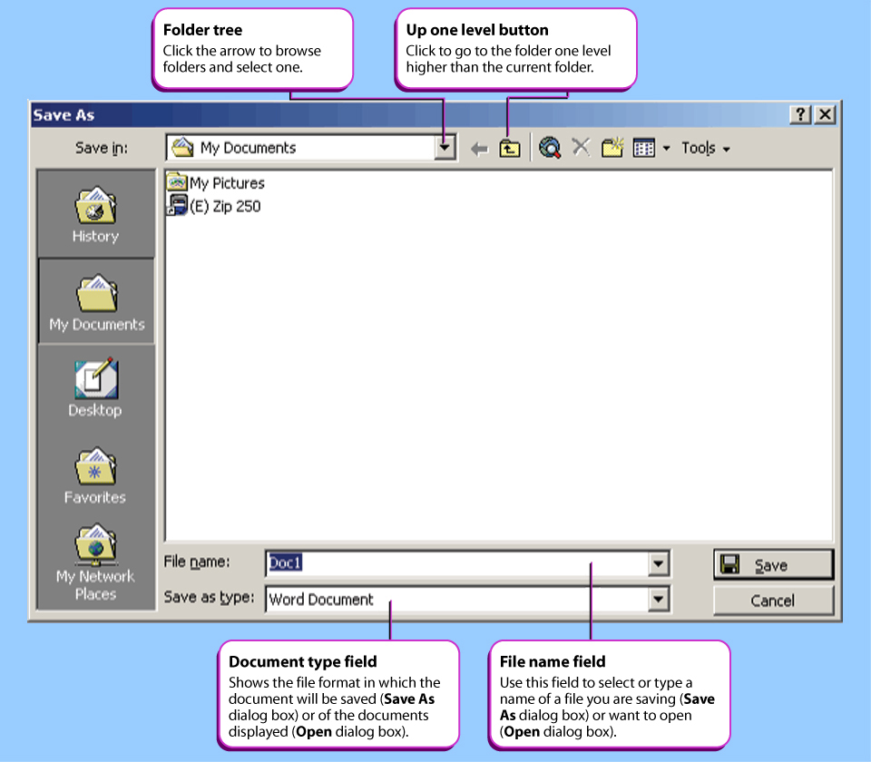

Some dialogue boxes are used to change system settings. These are often subdivided into tabbed categories, like a real-life folder or card file. Click on a tab to change from one section to another.
The following illustration shows the Microsoft® Windows® Date/Time Properties dialogue box:
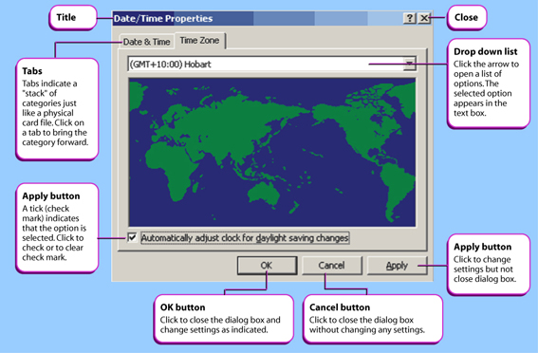

Make your cover page here and

add the following completed pages…

Save a link on your site to this document as your initials_compare.doc

A Summary of your comparison here:
Windows (Vista) vs. Macs (OSX):
There has been a lot of speculation of which operating system is the best for computing systems, among all the competitors two have made a name for themselves as the best which are the Mac and Windows operating system.

Traditionally Windows have been more widely distributed over Macs due to their software capabilities and their market appeal. Although Macs have been making a steady come back into the market many professionals are arguing that you can’t take over the computing market in a day or hour.

Windows has been widely advertised due to its dominance of the market and due to the media many people believe that Windows is the way to go but this is not always the case as the transition from XP to Vista hasn’t gone very smooth for many Windows users which has resulted in quite a lot of user frustration. One of these problems is the fact Windows Vista requires high hardware requirements for it to run at optimum settings. One of the major problems is RAM which Vista requires 1GB of which many older computers won’t necessarily have. Vista uses around 1GB just displaying the desktop and booting so multi-tasking becomes quite a problem for users who use multi-tasking frequently.

There are many areas where OS (Operating Systems) can compare such as User Interface, response time, compatibility and how user friendly that system is.

One of the major differences between OS’s is that their interface is quite different due to who the company will be targeting.

Since the release of these two new OS’s there has been a major difference in UI (User interfaces) although many Mac users accuse Windows off ripping ideas of the OS X operating system such as the widgets bar used at the bottom of the Mac desktop. Mac users accuse the windows sidebar as a rip of the idea and it may be true but it’s a very handy feature for checking performance, calendar dates and time. There are many comparisons to be made between these two systems but I would say that it all comes down to preference, if users prefer the Vista or Mac theme. Although changing operating systems due the UI is quite shallow in my opinion due to the fact that change can make or break your current set up.

Another issue is that response time; many users want their multi-tasking to be efficient and opening folders and files as quick as possible. This also depends on hardware which brings up another problem; Macs can be customised like a normal PC due to their strict hardware parts. Whereas with the Windows operating system adding RAM or another component can be easily done. Response time also is key factor when buying computers for a business due to the fact a 5-10s load time is considered long.

The third and final issue with operating systems is that compatibility as an issue every user will have to face at one point in time. Due to windows being the operating system to beat at the moment many software companies focus on making software for the leading OS which leads to many compatibility issues with Mac and Linux OS. Also the fact that windows released Vista, XP users will have problems getting software but not as much as Mac and other operating systems.

Overall the choice of operating systems comes down to user preference and the past experiences the user has had with computers.

4. A brief description of the differences between computer types
Write here

5. A list of the specifications on the computer system you use either in your room or the family computer.
Write here

Bibliography:
http://www.familyresource.com/lifestyles/technology/buying-a-home-computer-mac-vs-windows

